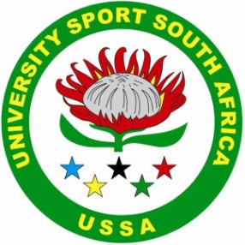 | USSA SURFING  (Affiliate of University Sport South Africa)  Private Bag X6531, GEORGE, 6530  Tel: (+27) 044 801 5037 / Fax: (+27) 044 805 6637  e-mail:hugo.loubser@nmmu.ac.za

USSA Surfing Results 2014
Men’s Competition

Teams
- Nelson Mandela Metropolitan University PE (NMMU PE ) 30 960
- University of Cape Town (UCT) 30 880
- Cape Peninsula University of Technology (CPUT) 22 680
- Varsity College (VC) 21 720
- Nelson Mandela Metropolitan University George Campus 16 760
- University of Stellenbosch (US) 15 120

Individual
- Jean du Plessis – NMMU PE
- Daniel Wilson - UCT
- Wade Simkiss – VC
- Bjorn Larsen – UCT

USSA Team

  - Jean du Plessis NMMU PE
  - Daniel Wilson UCT
  - Wade Simkiss VC
  - Bjorn Larsen UCT
  - Dom Notten VC
  - Jeandre Blignault CPUT
  - Jaco Steyn US
  - Dane van Greunen NMMU PE

Ladies’s Competition

Teams
- Varsity College 10 340
- UCT 10 020
- US 7 300
4. NMMU George 4 000
4. NMMU PE 4 000
6. CPUT 1 700

Individual
- Roxy Giles – NMMU George
- Nicole Pallet – Varsity College
- Jessica Lee –UCT
- Caryn Macnicol – Varsity College

USSA Team
  - Roxy Giles – NMMU George
  - Nicole Pallet – Varsity College
  - Jessica Lee –UCT
  - Caryn Macnicol – Varsity College

Overall Winner
Institutional team trophy donated by Robin de Kock

- University of Cape Town 40 900
- Nelson Mandela Metropolitan University (PE) 34 960
- Varsity College 32 060
- Cape Peninsula University of Technology 24 380
- University of Stellenbosch 22 420
- Nelson Mandela Metropolitan University George 20 760

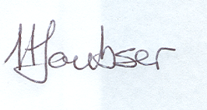
Hugo Loubser
USSA Surfing Chairperson

